**Evidence Gathering Document for SQA Level 8 Professional Developer Award.**

This document is designed for you to present your screenshots and diagrams relevant to the PDA and to also give a short description of what you are showing to clarify understanding for the assessor.

Each point that required details the Assessment Criteria (What you have to show) along with a brief description of the kind of things you should be showing.

Please fill in each point with screenshot or diagram and description of what you are showing.

**Week 2**

| Unit | Ref | Evidence |  |
| --- | --- | --- | --- |
| I&T | I.T.5 | Demonstrate the use of an array in a program. Take screenshots of:  *An array in a program  *A function that uses the array  *The result of the function running | |
|  |  | **Description:** | |

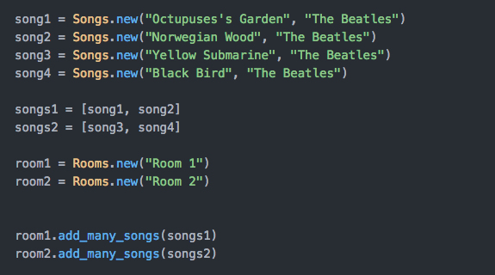**Paste Screenshot here**

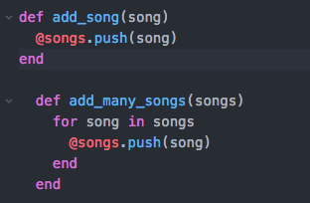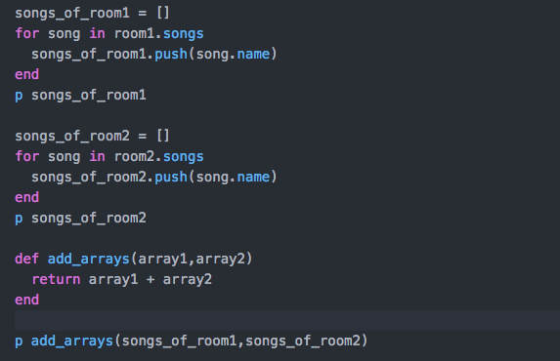

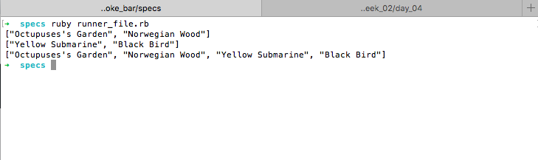

**Description here**

Here I created a Ruby Class of Songs and Rooms that are part of a Karaoke. In the left superior corner I created four songs with a name and an artists, and then I created two arrays (songs1 , songs2) made out of the songs. In the Room class I created methods to add one individual song or an array of rooms through two methods. In the image at the right I looped through the songs found in each room to create a new array of just the names of the songs in the room. At the bottom I created a “add array” method that took in two arrays and combined them.

In the last image which displays the console, I have an array of the song’s names of the first room and then the second room and then an array of the names of the songs for both rooms.

| Unit | Ref | Evidence |  |
| --- | --- | --- | --- |
| I&T | I.T.6 | Demonstrate the use of a hash in a program. Take screenshots of:  *A hash in a program  *A function that uses the hash  *The result of the function running | |
|  |  | **Description:** | |

**Paste Screenshot here**

**Description here**

**Week 3**

| Unit | Ref | Evidence |  |
| --- | --- | --- | --- |
| I&T | I.T.3 | Demonstrate searching data in a program. Take screenshots of:  *Function that searches data  *The result of the function running | |
|  |  | **Description:** | |

**Paste Screenshot here**

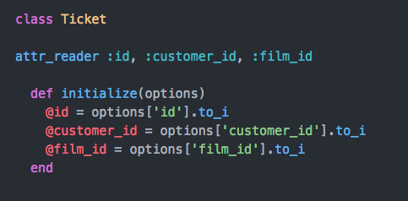

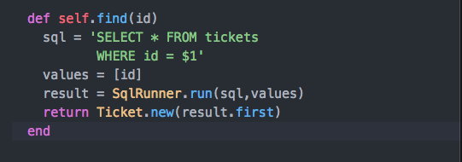

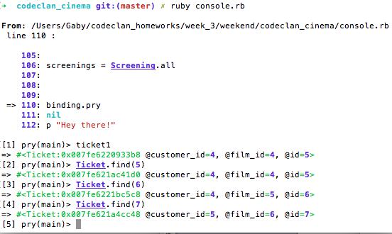

**Description here**

On week 3, we began to create SQL databases and write our code in Ruby. In the example above, there was a many to many relationship between the classes, where class Ticket stored the id of the customer and the film. I created a method in the Ticket class that aimed to find a specific ticket when it’s id was given as a parameter, which matched with my codeclan cinema database that I created for the project. The method takes the id given and returns an array of hashes as the ‘result’. Of this array of hashes I took the first and created a new Ticket object with it and then returned it. In the terminal, using pry, I can access the ticket1 that was created and then then through the find() methods I can display as with other tickets. As it has not real properties of it’s own but was dependent on the two other classes and the ids of the customers and the films.

| Unit | Ref | Evidence |  |
| --- | --- | --- | --- |
| I&T | I.T.4 | Demonstrate sorting data in a program. Take screenshots of:  *Function that sorts data  *The result of the function running | |
|  |  | **Description:** | |

**Paste Screenshot here**

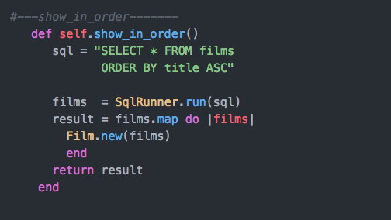

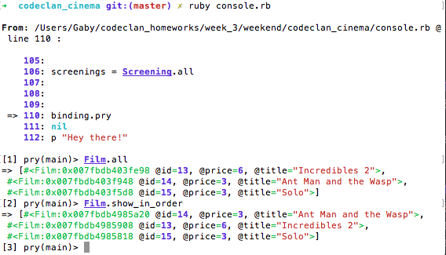

**Description here**

Following the project of the Codeclan Cinema, I created a method in the Film class that would take return an array of film objects arranged in alphabetical order. The method show_in_order()

Contrasts with self.all() because it uses SQL code to specify that the result should be in ORDER of the column that has the ‘Title’ values. This then again, returns an array of hashes, which I then map to create new Film objects. In the Terminal image I contrast both methods to see the effect that “ORDER BY title ASC” has on the order of the films.

**Week 5 and 6**

| Unit | Ref | Evidence |  |
| --- | --- | --- | --- |
| A&D | A.D.1 | A Use Case Diagram | |
|  |  | **Description:** | |

**Paste Screenshot here**

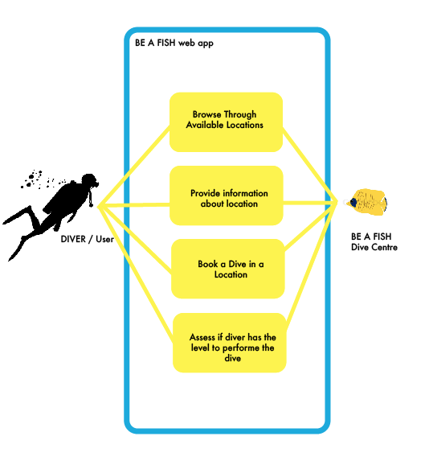

**Description here**

In the above image I depicted a use case diagram, which illustrates the most basic interactions among the elements of system, in this case the “Be A Fish” web application, and provides an overview of the usage requirements of the application. In this application there will give divers/users the possibility to view all the available diving locations that the dive center offers. Each location will also offer the difficulty of the dive and tell the schedule of the dive. The diver can book then a dive at a particular location for a particular time. The Dive shop can also see how many users are signed up for each scheduled dive in certain location. Update the list, delete divers, and update their information.

| Unit | Ref | Evidence |  |
| --- | --- | --- | --- |
| A&D | A.D.2 | A Class Diagram | |
|  |  | **Description:** | |

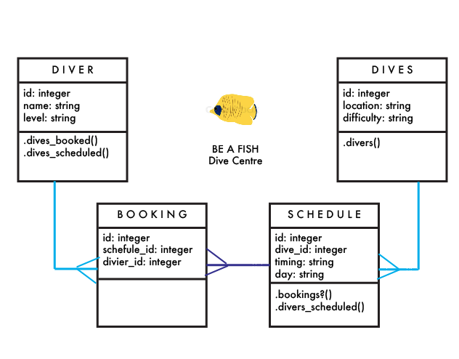

**Paste Screenshot here**

**Description here**

The diagram depicts a Class Diagram, where the structure of the web application Be a Fish is structured in different classes and the relationships between the classes as well as some methods included in each. In the web application there are four classes, *diver, divers*, *bookings* and *schedule.* Diver and booking is a one to many relationship, since 1 diver can have many bookings but a booking only has one diver, hence the @diver_id. A scheduled *dive* can have many bookings so it’s a one to much relationship again. Finally, dives has a many to one relationship with schedule, since one dive/location can have many scheduled dives. A new diver, booking,schedulre,dives all can be creates, updated, deleted and views. Specifically to each classes are certain methods, a diver can checked this bookings, and scheduled dives. A scheduled dive can view which divers go in that dive and how many bookings it has. And a Dive can check how many divers are going and check if they are prepared for the difficulty of the dive.

| Unit | Ref | Evidence |  |
| --- | --- | --- | --- |
| A&D | A.D.3 | An Object Diagram | |
|  |  | **Description:** | |

**Paste Screenshot here**

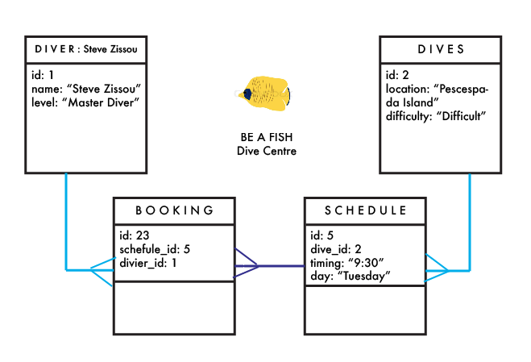

**Description here**

Using and object diagram here, we can see that a diver (“Steve Zissou”) who is a “Master Diver” (the highest level of diver) has made a booking for the scheduled dive to the Dive site “Pescespada Island” which is a difficult dive site and is scheduled for Tuesday at 9:30.

| Unit | Ref | Evidence |  |
| --- | --- | --- | --- |
| A&D | A.D.4 | An Activity Diagram | |
|  |  | **Description:** | |

**Paste Screenshot here**

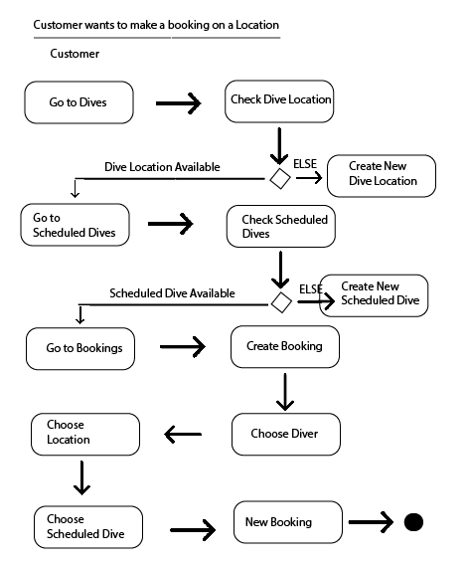

**Description here**

The Activity Diagram above follows the path of the customer when he/she would like to create a booking for a specific location. Initially the customer, if he had a dive location in mind, would have to check that that location is available in the dives. If it’s not, the customer would have to create it. If it is available he would have to check the scheduled dives for that specific location. If there is not scheduled dive for that location, the customer would have to create a scheduled dive for that location. After checking/creating the scheduled dive, the customer can then go to bookings to create a new booking. He would choose among the available dive locations, the scheduled dive for that location and the available divers to create a new booking. There is where the path to create a new booking ends.

| Unit | Ref | Evidence |  |
| --- | --- | --- | --- |
| A&D | A.D.6 | Produce an Implementations Constraints plan detailing the following factors:  *Hardware and software platforms  *Performance requirements  *Persistent storage and transactions  *Usability  *Budgets  *Time | |
|  |  | **Description:** | |

**Paste Screenshot here**

|  |  |  |
| --- | --- | --- |
| **FACTOR** | **DESCRIPTION** | **SOLUTION** |
| Hardware and software platforms | The aesthetics of the app and the views could vary between different platforms, changing the display and functionality of the app. | Seek information about styling in CSS and test many different possibilities, sizes and platforms. |
| Performance requirements | If the app uses a lot of images this can slow the app. This can discourage users to using the page. | The use of CSS is reduced and standard for all pages. Images are of smaller resolution and standard for the ‘viewing’ pages. |
| Persistent storage and transactions | The information of users has to be very basic and it’s available for everyone to see so there is not possibility of privacy for users, if there was any sensible information it could present a problem | As the app will be use for organizational purposes, there won’t be any sensible information submitted. |
| Usability | Many users can get detracted from using an app because the paths between actions could not be clear, especially when updating certain divers would be within the diver profile. | As this app needs to be functional and useful, the usability of it has to be straightforward. One strategy would be to test the app with different users and get their feedback, to find the best flow for actions. |
| Budgets | There is no budget included in the project to outsource or for consultations. This could manifest in the quality of the finished product. | Acknowledging this limitations and could be counterbalanced by the support provided by peers as well as instructors. |
| Time | As the project had to be developed in a weeks time, there was some constraints to deliver the full functionality of the app as well as the aesthetics of it. | Functionality was prioritized over aesthetics, to finish the MVP. |

**Description here**

| Unit | Ref | Evidence |  |
| --- | --- | --- | --- |
| P | P.5 | User Site Map | |
|  |  | **Description:** | |

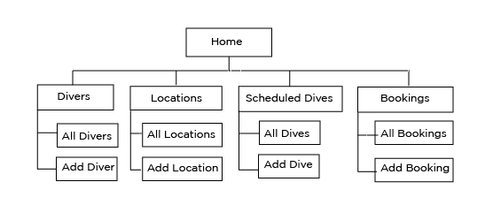

The diagram shows “Be a Fish” navigations buttons. It initially starts at the home, and then there, which is also a button at the Navigations Bar to always come back to this preview. All the buttons follow the same principles: a display page and a form page. In the “All..” buttons, all entries can be seen, linking them with specific details. In the “Add..” buttons, the customer can create a new entry of each category.

| Unit | Ref | Evidence |  |
| --- | --- | --- | --- |
| P | P.6 | 2 Wireframe Diagrams | |
|  |  | **Description:** | |

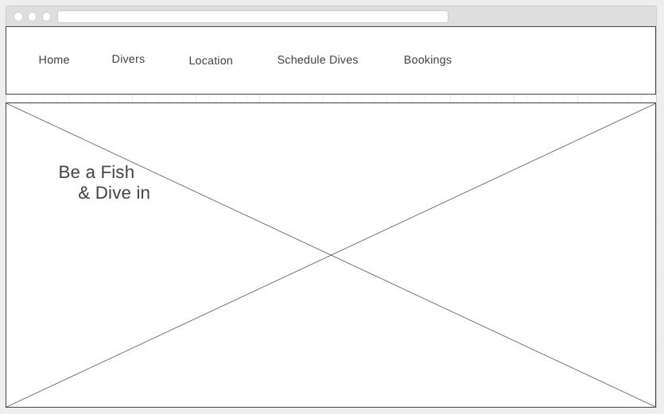

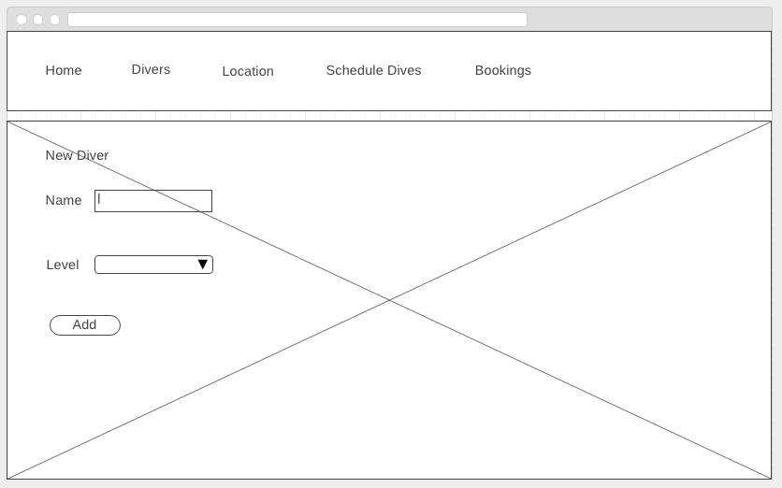

**Description here**

Here are two examples of the wire frames for two views of the app “Be a Fish” . The top one corresponds to the “/home” / Home view, which displays the Navigation Bar with all the buttons to take to the other display pages as well as the forms. It has an image with a catch phrase for the name of the business. The second one display shows the form to create a new diver, which has a input to put the name (a string) and a select bar where there will be displaying the different types of levels that a diver can have. At the button there is a submit button which will add a new diver to the database.

| Unit | Ref | Evidence |  |
| --- | --- | --- | --- |
| P | P.10 | Example of Pseudocode used for a method | |
|  |  | **Description:** | |

**Paste Screenshot here**

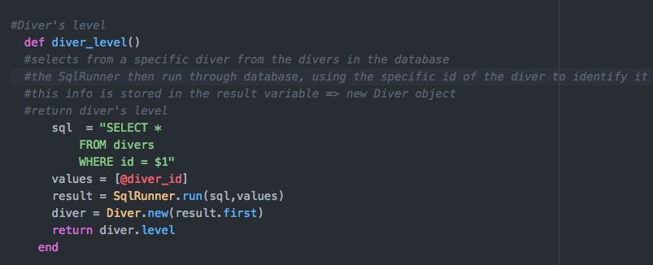

**Description here**

This method in my app was created to return the level of the diver that if part of a booking. It’s located in my “Booking” model, since I want to know if the diver is for the dive according to it’s level of difficulty. I wrote want I wanted the method to deliver, and how it was to deliver it.

| Unit | Ref | Evidence |  |
| --- | --- | --- | --- |
| P | P.13 | Show user input being processed according to design requirements. Take a screenshot of:  * The user inputting something into your program  * The user input being saved or used in some way | |
|  |  | **Description:** | |

**Paste Screenshot here**

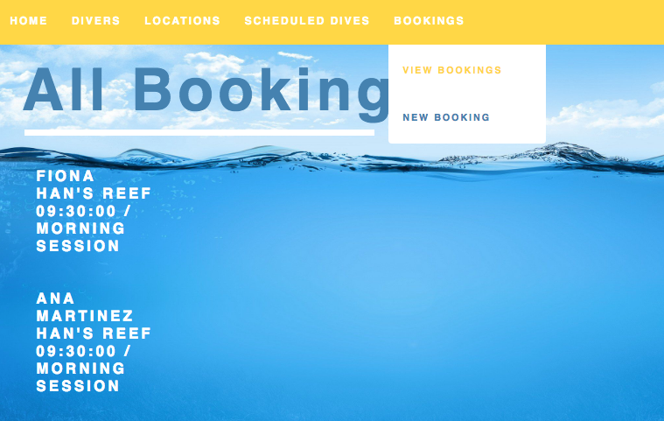

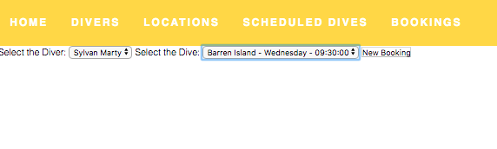

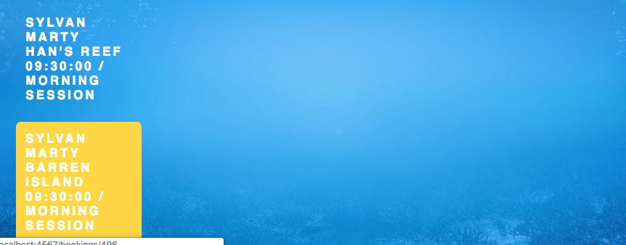

**Description here**

The initial image shows where the used would go to make a new booking.

The second image shows the form (without CSS) that asks the customer to select the diver from the pool divers in the d atabase; also it selects one of the scheduled dives. It creates a new Booking. The last image shows all the Bookings and it shows the diver (Sylvan Marty / Schedule Dive).

| Unit | Ref | Evidence |  |
| --- | --- | --- | --- |
| P | P.14 | Show an interaction with data persistence. Take a screenshot of:  * Data being inputted into your program  * Confirmation of the data being saved | |
|  |  | **Description:** | |

**Paste Screenshot here**

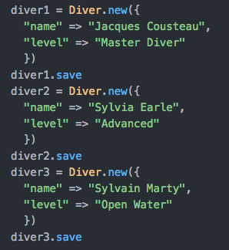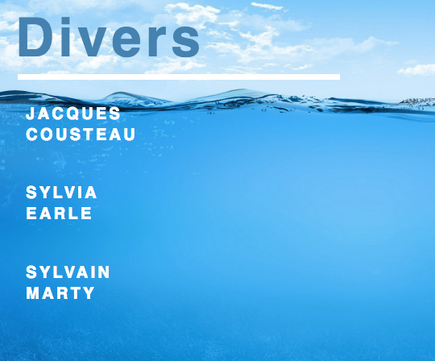

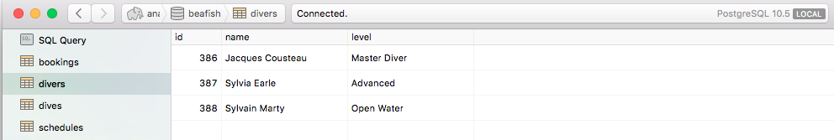

**Description here**

I created a seed.rb as part of the database where I saved three divers. Using Postico in the lower image the names of the divers and their diving level appear. As well in the far right image of the app where there names also are displayed.

| Unit | Ref | Evidence |  |
| --- | --- | --- | --- |
| P | P.15 | Show the correct output of results and feedback to user. Take a screenshot of:  * The user requesting information or an action to be performed  * The user request being processed correctly and demonstrated in the program | |
|  |  | **Description:** | |

**Paste Screenshot here**

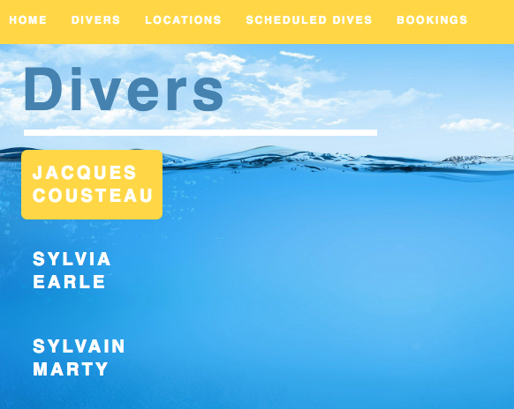

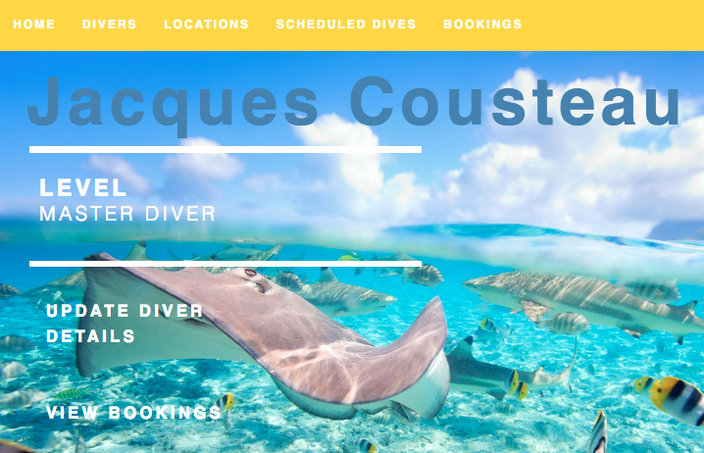

**Description here**

Here the customer selects the diver that he wants to see information of. As he clicks on the name, the details of the diver appear, where the customer can also update the divers details and view his bookings.

| Unit | Ref | Evidence |  |
| --- | --- | --- | --- |
| P | P.11 | Take a screenshot of one of your projects where you have worked alone and attach the Github link. | |
|  |  | **Description:** | |

**Paste Screenshot here**

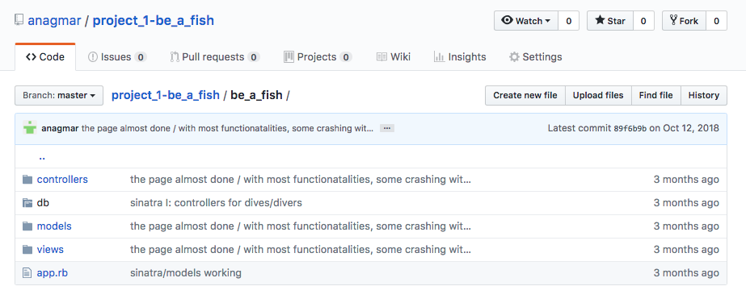

https://github.com/anagmar/project_1-be_a_fish/tree/master/be_a_fish

**Description here**

Image of my solo project with uploaded to my repository in GItHub and the link to it accordingly.

| Unit | Ref | Evidence |  |
| --- | --- | --- | --- |
| P | P.12 | Take screenshots or photos of your planning and the different stages of development to show changes. | |
|  |  | **Description:** | |

**Paste Screenshot here**

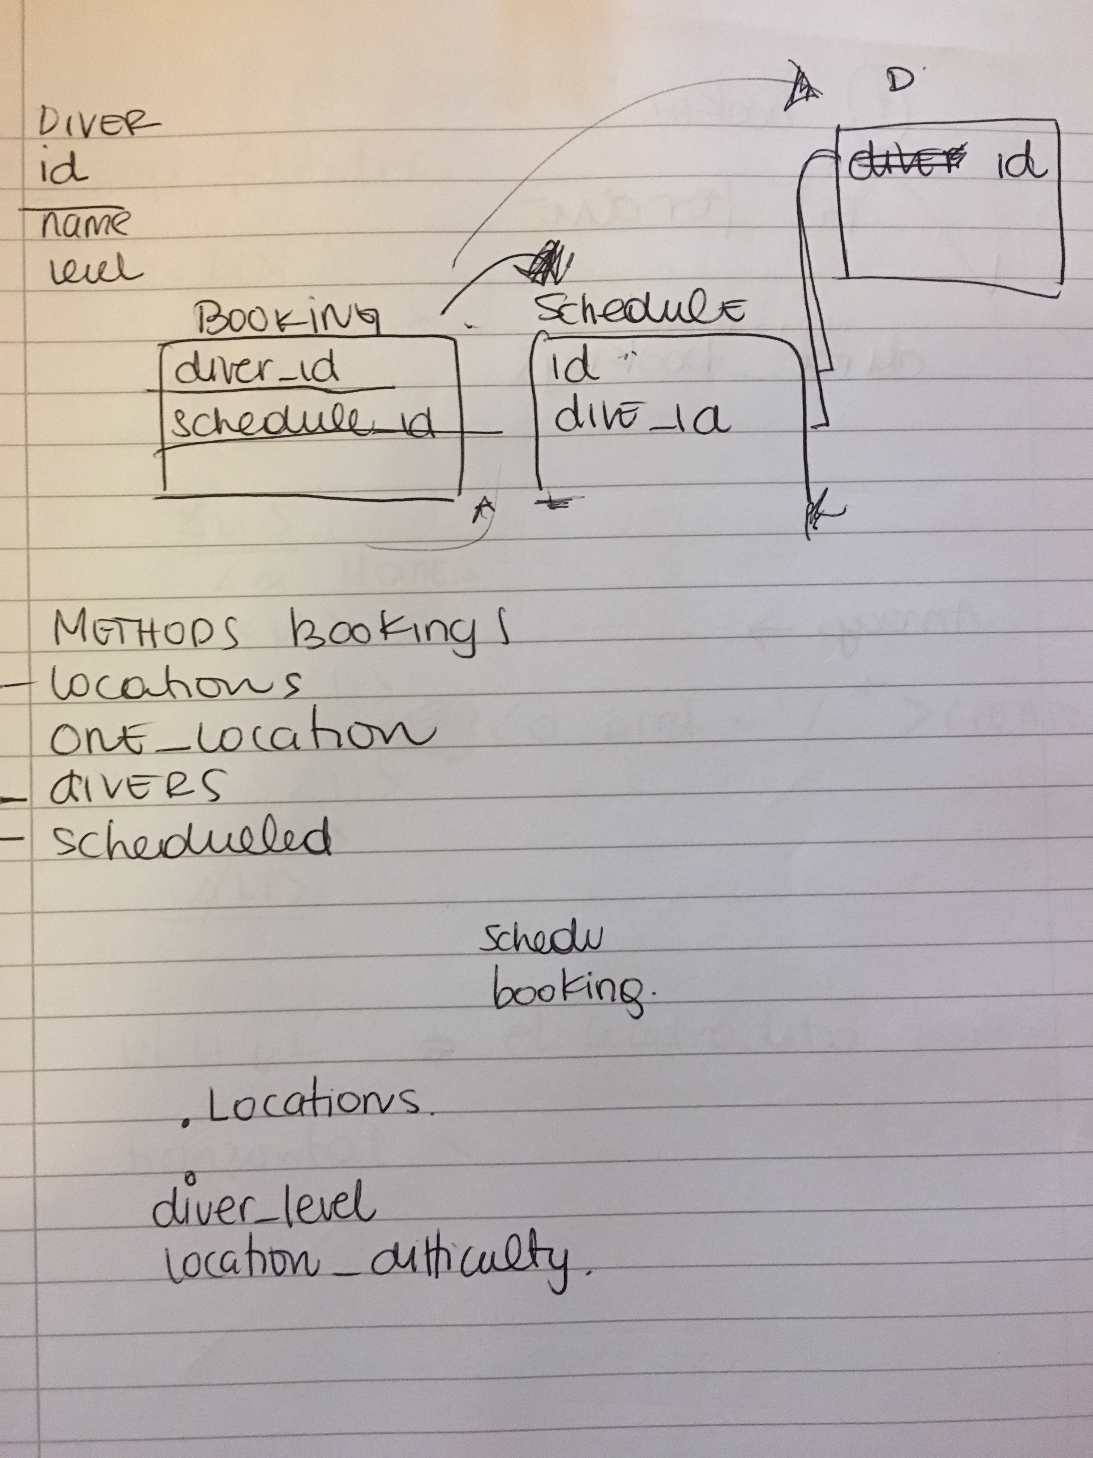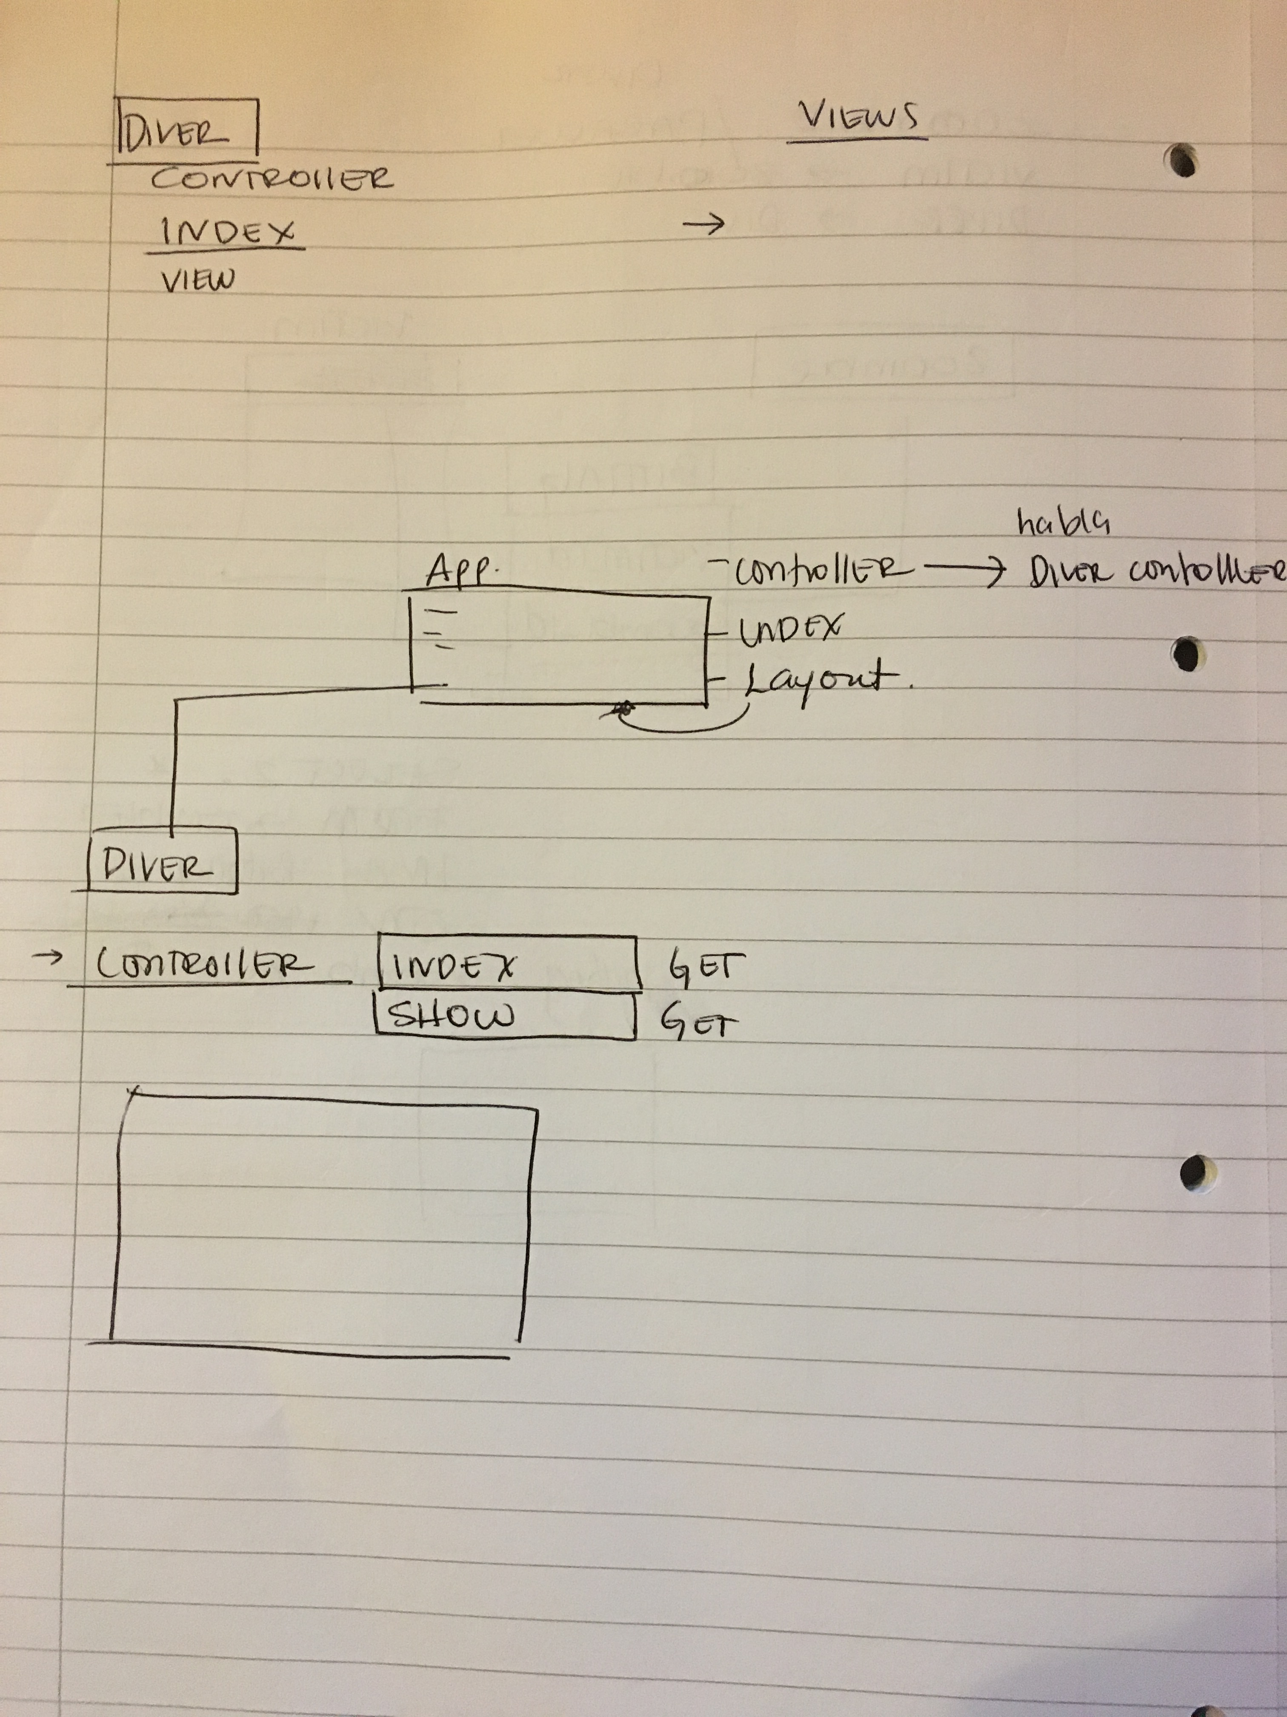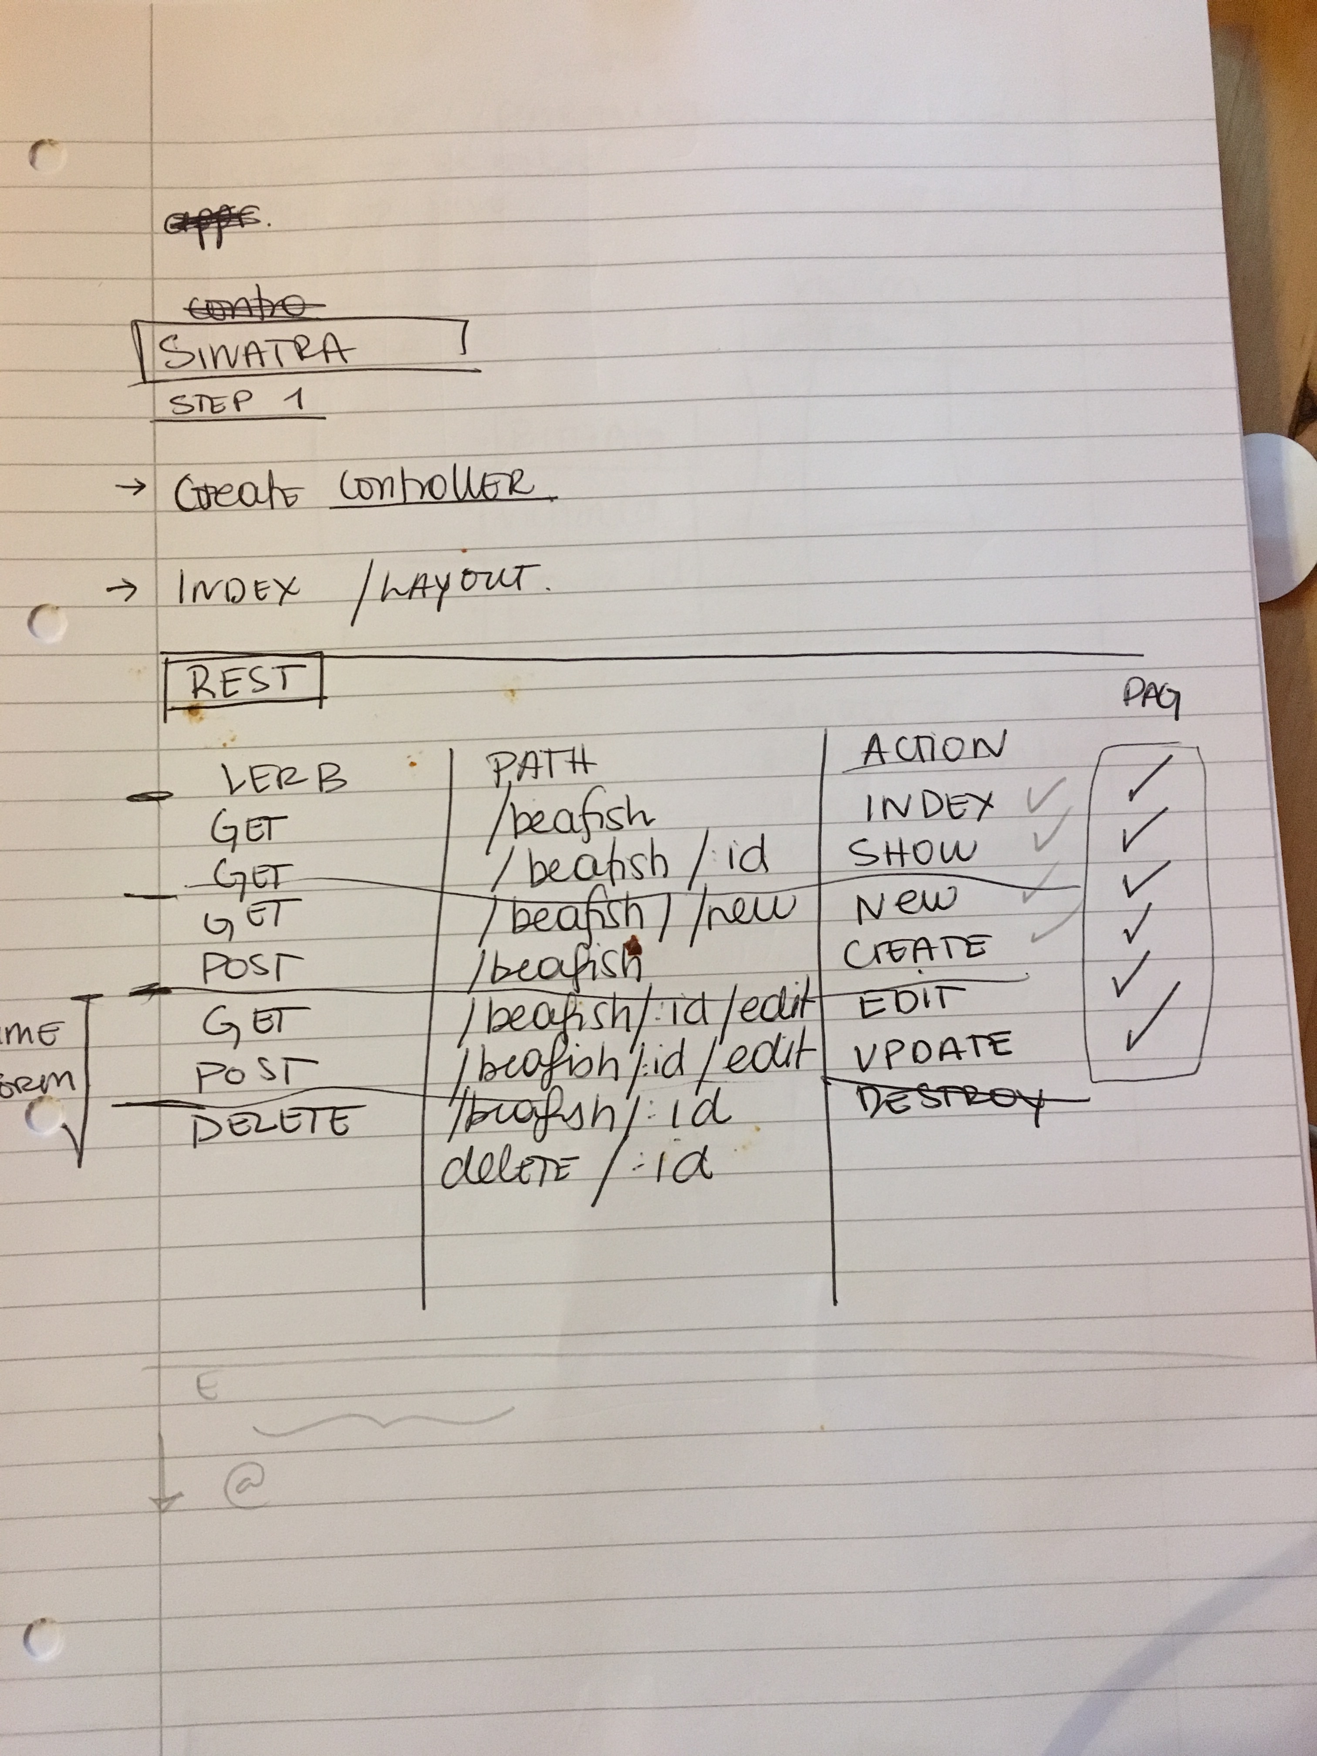

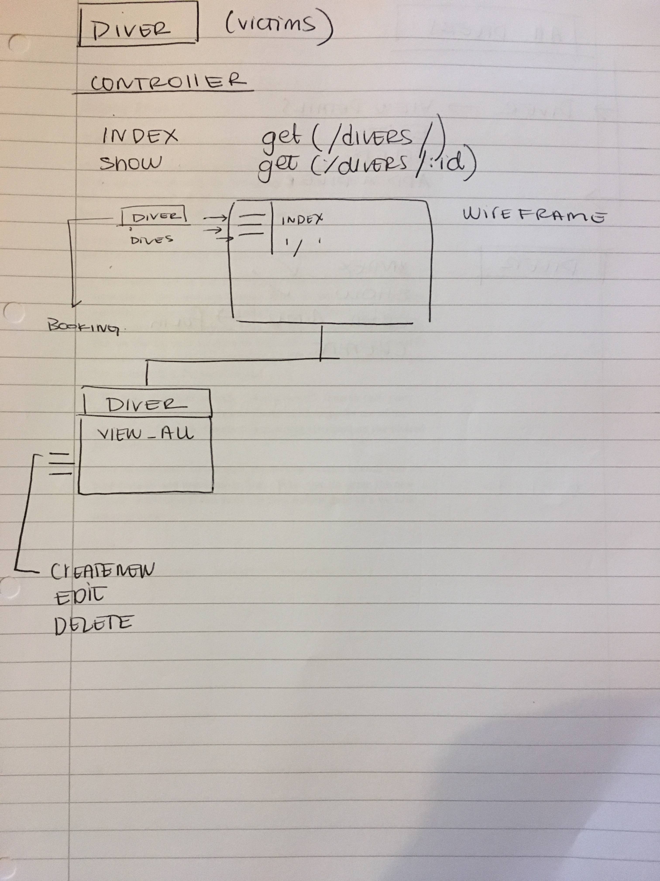

**Description here**

The above image show some diagrams that I made to make sense of what was going on in the APP. I knew that the App should have divers, locations and bookings. I made a model to understand the relationship one to many / one to one relatioships. It was similar to a project we did before with a Cinema so I based it on that. I then came to see which method each of the four models should have and the RESTful routes that each model should have and how they would relate with one another. Then the other images show the possible wireframes of each view and how they would connect with one another.

**Week 7**

| Unit | Ref | Evidence |  |
| --- | --- | --- | --- |
| P | P.16 | Show an API being used within your program. Take a screenshot of:  * The code that uses or implements the API  * The API being used by the program whilst running | |
|  |  | **Description:** | |

**Paste Screenshot here**

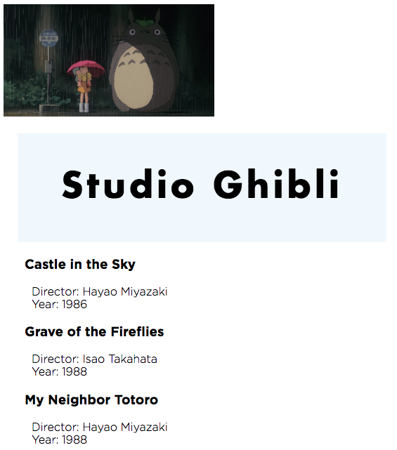

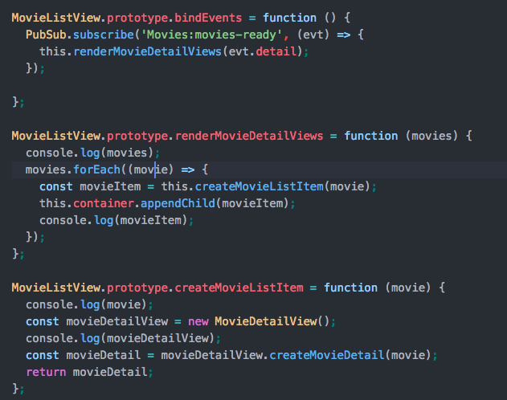

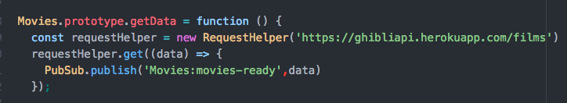

**Description here**

For this app I used the API for the Ghimbli Studios of all the movies produced by the studio, which provided all the info for each movie. I first get the API in my Movie model as a getData() function. Using PubSub helpers, the data is then published and MovieListView Model substribes to this channel. After getting this data another model, MovideListView renders the information of the movies, as a MovieDetailView for each of the elements in the array of movies provided by the API.

| Unit | Ref | Evidence |  |
| --- | --- | --- | --- |
| P | P.18 | Demonstrate testing in your program. Take screenshots of:  * Example of test code  * The test code failing to pass  * Example of the test code once errors have been corrected  * The test code passing | |
|  |  | **Description:** | |

**Paste Screenshot here**

**Description here**

**Week 9**

| Unit | Ref | Evidence |  |
| --- | --- | --- | --- |
| P | P.1 | Take a screenshot of the contributor’s page on Github from your group project to show the team you worked with. | |
|  |  | **Description:** | |

**Paste Screenshot here**

**Description here**

| Unit | Ref | Evidence |  |
| --- | --- | --- | --- |
| P | P.2 | Take a screenshot of the project brief from your group project. | |
|  |  | **Description:** | |

**Paste Screenshot here**

**Description here**

| Unit | Ref | Evidence |  |
| --- | --- | --- | --- |
| P | P.3 | Provide a screenshot of the planning you completed during your group project, e.g. Trello MOSCOW board. | |
|  |  | **Description:** | |

**Paste Screenshot here**

**Description here**

| Unit | Ref | Evidence |  |
| --- | --- | --- | --- |
| P | P.4 | Write an acceptance criteria and test plan. | |
|  |  |  | |

**Paste Screenshot here**

**Description here**

| Unit | Ref | Evidence |  |
| --- | --- | --- | --- |
| P | P.7 | Produce two system interaction diagrams (sequence and/or collaboration diagrams). | |
|  |  | **Description:** | |

**Paste Screenshot here**

**Description here**

| Unit | Ref | Evidence |  |
| --- | --- | --- | --- |
| P | P.8 | Produce two object diagrams. | |
|  |  | **Description:** | |

**Paste Screenshot here**

**Description here**

| Unit | Ref | Evidence |  |
| --- | --- | --- | --- |
| P | P.17 | Produce a bug tracking report | |
|  |  | **Description:** | |

**Paste Screenshot here**

**Description here**

**Week 12**

| Unit | Ref | Evidence |  |
| --- | --- | --- | --- |
| I&T | I.T.7 | The use of Polymorphism in a program and what it is doing. | |
|  |  | **Description**: | |

**Paste Screenshot here**

**Description here**

| Unit | Ref | Evidence |  |
| --- | --- | --- | --- |
| A&D | A.D.5 | An Inheritance Diagram | |
|  |  | **Description:** | |

**Paste Screenshot here**

**Description here**

| Unit | Ref | Evidence |  |
| --- | --- | --- | --- |
| I&T | I.T.1 | The use of Encapsulation in a program and what it is doing. | |
|  |  | **Description:** | |

**Paste Screenshot here**

**Description here**

| Unit | Ref | Evidence |  |
| --- | --- | --- | --- |
| I&T | I.T.2 | Take a screenshot of the use of Inheritance in a program. Take screenshots of:  *A Class  *A Class that inherits from the previous class  *An Object in the inherited class  *A Method that uses the information inherited from another class. | |
|  |  | **Description:** | |

**Paste Screenshot here**

**Description here**

| Unit | Ref | Evidence |  |
| --- | --- | --- | --- |
| P | P.9 | Select two algorithms you have written (NOT the group project). Take a screenshot of each and write a short statement on why you have chosen to use those algorithms. | |
|  |  | **Description:** | |

**Paste Screenshot here**

**Description here**